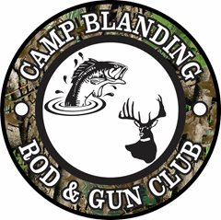
Always call the Hotline
when planning your hunting or fishing trip.
Do not enter any area that’s closed.
Hotline: (904) 682-3318
FWC Violations: (904) 359-3883
CWD (Chronic Wasting Disease) Reporting:
(866) 293-9282 MyFWC.com/CWD

Allan Hallman (Post FWC Biologist)
Bldg 4396, Ave D
Work Cell: (386) 623-0132
Office: (904) 533-2768
Personal Cell: (904) 838-7872

Lowry & Magnolia Lakes: These ponds are FWC controlled.

Blue Pond open dates:
26-29 May
24-26 Jun
1-4 & 22-24 Jul
19-21 Aug
01-04 Sep
23-24 Sep
30 Sep - 02 Oct

