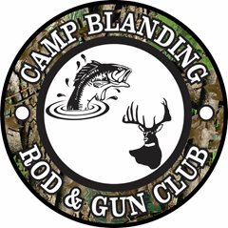
Always call the Hotline
when planning your hunting or fishing trip.
(904) 682-3318
Do not enter any area that’s closed.
FWC Violations: (904) 359-3883

Lowry & Magnolia Lakes: These ponds are FWC controlled.

Blue Pond open dates:
26-29 May
24-26 Jun
1-4 & 22-24 Jul
19-21 Aug
23-24 Sep
30 Sep - 02 Oct

